**Project Report**

**Introduction to Software Engineering**

**Fall 2022**

**Group Members:**

Wasayef Ashtairy 100053668

Natnael Takele 100058082

Noah Yohannes 100053689

Ahmed Fadhel 100058802

**Instructor:** Dr Davor Svetinovic

**Submitted Date:** 09/12/2022

Contents

**Abstract** 1

**Feasibility Study** 1

Benefits 1

Technical Feasibility 2

Resources and Outline 2

Alternatives & Risks 3

**Requirements Phase** 3

Use-cases 5

Use-case Diagram 6

**Design phase** 12

**Software Demo** 18

Demo for Desktop App 18

Demo for Android 22

Conclusion 26

Appendix 27

PlantUML code used in Visual Studio Code 27

# **Abstract**

The main objective of this project is to help parents monitor their children at work. It records the temperature of the kid(s) and notifies the parents on the condition that said temperature exceeds a specific degree or alerts them of mealtime. Only the parents are allowed access to the system with pre-registered credentials as a safety protocol.

The tools and resources used for the project are a programming IDE, a live camera, GitHub, and Stack overflow. We barely paid anything, except for an Apple Membership, to make our app downloadable on their devices. The project works as intended. We've noticed no flow after multiple tests**.**

# **Feasibility Study**

The project intended to be built is a child monitoring system. The project clients are parents who will keep an eye on and monitor their child’s well-being from a remote location through this system. The system we are designing is a software system that meets the demands of the parents.

**Scope**:

The project will be built on the assumption that the camera is to be installed by the parents. The child monitoring system covers the baby’s room and is controlled by the parents. It does not interact with the nanny of the baby, nor does it monitor the baby outside his room. The system provides functionalities such as receiving a real time video from the monitoring camera, using sensor data to monitor the body temperature of the baby and notify parents if the baby is crying. The remote monitoring system is dependent on the feed from the camera video and sensors in the camera. Additionally, the system will maintain the privacy of the video feed obtained.

The project will use a small timeframe and minimized budget that guarantees delivery of the required qualities. Therefore, the expertise scope of the project is bound to the parents and the system engineers. Mouza being a lawyer could guide the developers on the quality of the privacy guidelines.

## Benefits

The principal benefit of the system is that it allows the parents to easily monitor their child. Hence, it saves time and effort. The system is flexible and easy to use. That is, the clients may run the system through their devices using the remote monitoring system. This is simple since the system and the devices are integrated, which offers smooth functionality. Additionally, the system employs alert notifications to inform the parents about the condition of their child, such as the timing of the next meal, or other alerts such as their child’s body temperature. Furthermore, our system is a multi-device program that can be operated on various devices, which means that both parents may access the system and monitor their child with total confidence and trust. The system prevents incidents from occurring or, at the very least, ensures the health and well-being of the child.

## Technical Feasibility

We will follow the reuse-oriented approach because we can reuse certain previously developed monitoring systems, such as the camera and other sensors in the system, with some additional adjustments based on the client's demands. Moreover, this approach results in a quick delivery technique with little cost and risk.

## Resources and Outline

The project will use Git version control through the GitHub hosting service to manage the project development and enhance collaboration among team members. Locally, the project will use the git bash application in Visual Studio Code to interact with the changes made to the project to GitHub. For the system design and implementation, we will use Java programming language and Eclipse IDE.

A human resource of system developers is required to build this system. Besides, the financial cost of the project is mainly invested in system engineers who design and implement the system.

The project has four primary phases. The first phase delivers the feasibility study followed by the requirements document. Once the requirements are clearly defined, the project will move into the design phase. Finally, the proposed design will be implemented to produce a prototype of the system.

Table 1. Tentative Timeline

|  |  |  |  |
| --- | --- | --- | --- |
| Feasibility Report | Requirements and Specification | System Design | Prototype implementation and Delivery |
| 04/11/2022 | 11/11/2022 | 20/11/2022 | 09/12/2022 |

## Alternatives & Risks

The major risks are lacking the ability to complete the project before the deadline, and potential security breaches by third parties. Other risks are the sensors providing inaccurate readings and the unavailability of an internet connection. The former results in unnecessary notifications, disturbing the parents, and the latter renders the whole system non-functional. Some customers might not be satisfied with the product. The alternatives are to work on an already existing system by adding or deleting features and hiring experienced programmers from outside the group.

# **Requirements Phase**

This paper presents the second phase of the child monitoring system, the requirements of this project. First, the user requirements are presented followed by the system requirements, both functional and non-functional requirements. Furthermore, the domain requirements are presented. A detailed use-case analysis is also presented to specify the behavior of the child monitoring system. Data dictionary and requirement table sections are also presented.

**User Requirements**

The user requirements are requirements written for the users of this project, that is the parents. Those requirements are described below.

1. The system must provide means to monitor the child’s temperature and send notifications if abnormal temperature readings were obtained.
2. Parents must have the option to view the live video feed on their devices.
3. The system must provide and follow security measure and protocols to ensure the family’s privacy and safety from malicious parties.
4. Facility should be provided for the parents to receive a notification of the baby’s mealtime.

**System requirements: Functional Requirements**

System requirements are requirements that set out a detailed description of the system’s functions, services, and operational constraints. The system requirements are described below.

1. System should display live streaming on the screens of remote devices, with the user having complete access to that stream and being able to see it from the camera at any time
2. Notifications received and shown on mobile devices are linked to the system placed on these devices, which alerts parents if their baby's temperature rises beyond 37 degrees, which is considered normal for kid
3. Depending on the seriousness of the notice, a notification can produce a sound and display as a warning if the child's temperature rises to the danger range of above 37.5 degrees or below 36.5 degrees.

**System requirements: Non-Functional Requirements**

The project gives high attention to meeting the non-functional requirements to meet the client’s expectation. The non-functional requirements listed below are considered critical to create an effective product. Hence, these requirements are quantified to make them easily verifiable in the prototyping phase.

1. The system shall maintain the privacy of the information with an authentication system.
2. The system must be accessed only from two accounts, parents’ account.
3. The system requires a minimum of 3mbps to send clear audio and video feed.
4. The system shall not be late by more than 10 seconds to send notifications to the parents.
5. The system should not crash more than once in a month.
6. The system should boot in in a time less than 10 seconds.
7. The user should be able to use the system with 30-minutes of training.

**Domain requirements:**

Requirements that come from the application domain of the system and that reflect characteristics of that domain. The domain requirements are obtained from the application domain of the baby's monitoring system and represent the features that are characteristic of the baby monitoring system. The domain requirements are presented below.

1. The system monitors only the baby’s room where the camera is installed or otherwise the system will be useless.
2. The system must follow all national privacy regulations because the rights of the user (the data subject) are protected by privacy laws regarding the fair and legal acquisition and use of their private details by organizations.

**Use Case Analysis**

The use-case analysis presented below defines the behavior of the child monitoring system.

***Actors****:* There are two groups of actors for our system.

***Primary actors:***

* The parents
* The monitoring software(system)

***Secondary******actor****:*

* The camera system

## Use-cases

* Login
* Open live feed
* Send notifications

## Use-case Diagram

**Use Case 1:**

* ***Name:*** Login to the system
* ***Description:*** The login/register use case is realized in this use case. The user must first choose whether they are a first-time user or have an account. Second, if the user already has an account, it will open in a matter of seconds. If not, a registration form will ask the user to provide a username and password. Finally, the screen will display the live stream.
* ***Actors:*** User (Parents), system - ***Pre-Conditions:*** User is logged in - ***Post-Conditions:***

The system has successfully registered the user.

The user has access to the system's functionality.

* ***Successful path:*** 
  1. If the user is new, it requests user to be registered.
  2. The system requests the user's personal information.
  3. The user provides personal information, including the desired credentials (username/password), and submits the registration process.
  4. The system distinguishes between various users and stores them in the system database accordingly, and registration is successful.
* ***Alternative path:***
* Invalid Username/Password

If the system cannot discover the name or the password during the basic flow, an error message is presented. When there are more than two people registered, the system displays an error indicating that the number of users has exceeded the limit. The actor has the option of entering a new name or password, or cancelling the procedure, at which time the use case closes.

* ***Exceptions:*** No or very slow internet connection. - ***Rules:***

No more than 2 users can register in the system

Username must be different than the password

**Use case 2:**

* ***Name***: Open Live-Feed
* ***Description***: The monitoring system will fetch the video and audio data from the remote camera system and display it on the screen. First, the parents select open feed. If the camera system in the child’s room is connected to the monitoring software, the video will be displayed on the screen.
* ***Actors***: User (Parents), The monitoring system, The camera system
* ***Pre-Condition***: at least one parent is logged in
* ***Post***-***Condition***: parents can see the live video feed

- ***Successful*** ***path***:

1. Parents Login request
2. Monitoring software displays available options to parents
3. Parents choose open live feed
4. the system opens the data from the camera system
5. Parents can now see the real-time feed

* ***Alternative*** ***path***:
  1. Error message will be displayed for invalid credentials following step 1
  2. Data such as video, audio, not available from the camera system following step 3
* ***Exceptions*** 
  1. No feed from the camera system. The system is disconnected.

***- Rules***

System needs to be active all the time

**Use Case 3:**

* ***Name:*** Notification
* ***Description:*** The notification use case is implemented in this use case. The system receives live temperature recording as an input from the baby’s room. Out of the ordinary temperature levels are sensed by the system and immediately the system sends notification to the parents. Moreover, when the baby’s mealtime approaches the system notifies the parents. This functionality is integrated with the sensors in the camera system.
* ***Actors:*** User, System
* ***Pre-Conditions:*** User is logged in.
* ***Post-Conditions:*** System successfully sends notification to the parents.
* ***Successful path:*** 
  1. The system receives temperature reading from the camera as an input
  2. The system decides if the temperature reading is out of the range of healthy child’s temperature reading.
  3. The system sends notification to the parents.
  4. The system keeps track of time.
  5. It sends notifications/reminders to the parents indicating it’s the baby’s mealtime, according to time intervals set by the parents while configuring the system.
* ***Alternative path:***

If the system doesn’t detect a temperature recording that is not out of the ordinary, it will only provide the temperature reading in the notification section.

* ***Exceptions:*** Without an internet connection the system will not be able to send a notification to the parents.
* ***Rules:***

There must be a constant temperature recording input to the system. Thus, there must be a strong internet connection.

The baby mealtimes must be already set by the parents.

**Data** **Dictionary**

|  |  |  |  |
| --- | --- | --- | --- |
| Name | Description | Type | Date |
| Users | the names of the users with a login account who will use the system | Entity | 10.11.2022 |
| System engineer | the person that develops and maintains the system | Entity | 10.11.2022 |
| camera | A device setup  system up in the child’s room | Entity | 10.11.2022 |
| Alert system | A way of displaying notification on screen | Attribute | 10.11.2022 |
| Data storage | A way to keep older recordings of the child’s room | Attribute | 10.11.2022 |

**Requirements table**

|  |  |  |  |  |
| --- | --- | --- | --- | --- |
| Baby Monitoring System Requirements | | |  |  |
| # | Id | Name | Text | Satisfied By |
| 1 | S0.0 | Original Statement | * A Client login/register to the baby monitoring system - System receives video feed. * User opens video feed * Display video on screen * System sends notification |  |
| 2 | S1.0 | User  registration/logging | User registration/logging in is performed by the system | System |
| 3 | S2.0 | Live video feed | Video is recorded by the cameras | System cameras |
| 4 | S3.0 | Display video on screen | System displays video screen | System, client’s devices |
| 5 | S4.0 | Cameras sense temperature | System cameras senses temperature | System cameras |
| 5 | S5.0 | Notification | The system sends notification | System |

# **Design phase**

**UML class diagram**

The structure of the baby well-being monitoring system can be modelled using the UML class diagram. The behavior of the system was studied. Then the classes, attributes, operations of the system, and the relationship between the classes were identified. These characteristics and relationships of the system are presented in the UML class diagram, which was obtained using VS code with PlantUML extension.

**Sequence Diagrams**

After grouping use cases to functional subsystems, a sequence diagram was developed for every use case. This helped to define the subsystems’ interfaces. The sequence diagrams of the four use-cases of the baby well-being monitoring system are presented below:

**Use case 1: Login to the system**

1. The parents provide their username and password
2. The parents click on the Login option
3. The system validates the entered credentials
4. The System directs the parents to the home page

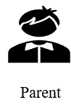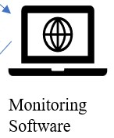

Enter credentials

Verify credentials

**Use case 2: Open live feed**

1. The parents click on the option to open live feed from the main page
2. The system displays the video feed



Open live feed

Display Live feed

**Use case 3: Show Notifications**

1. The system sends notification in case of abnormal child’s body temperature 2. The system sends alerts of the baby’s mealtime to the parents

send notifications



**State Diagrams**

Since use case 1, log in to the system, logically precedes the other two use cases, we have started building the state diagram by analyzing use case 1.

Use case 1: Login to the system

1. The parents provide their username and password
2. The parents click on the Login option
3. The system validates the entered credentials
4. The System directs the parents to the home page

Start

Waiting for Login

credentials

Insert credentials

Invalid

credentials

**Verification**

**Use case 2: Open live feed**

1. The parents click on the option to open live feed from the main page
2. The system displays the video feed

Start

Waiting for Login

credentials

Verification

Insert credentials

Invalid

credentials

]

Login Successful

[

Display main page

∞

Open live feed

Video feed displayed

**Use case 3: Show Notifications**

1. The system sends notification in case of abnormal child’s body

temperature

2. The system sends alerts of the baby’s mealtime to the parents

Start

Waiting for Login

credentials

Verification

Insert credentials

Invalid

credentials

]

Login Successful

[

Display main page

∞

Open live feed

Video feed displayed

Display Notifications

[

Abnormal

temperature

]



# **Software Demo**

As described in the Feasibility Study, the team decided to re-use existing code for this option. We are attempting to construct our system in two ways. Using the Java JFrame library and Android Studio The screenshots of the user interface are shown below, along with notes describing the UI. There system has an android app and a desktop app

## Graphical user interface, text, application, email Description automatically generatedDemo for Desktop App

**1**

**2**

**The above window will appear next, requesting the user to provide personal information, including the requested credentials (username/password), for completing the registration process.**

**This is the primary menu through which the user may access the Login Screen. To begin enrolling in the system, the parent must choose the Parent Login option.**

**3**

**If the system cannot find the user's name or password during the basic flow, an error message is sent to the user, as seen below.**

**4**

**After logging in, the user is provided with three main options. The first choice is to open the live feed, and the second is to display the notifications. The user can go back to the main page using the *Exit* button**

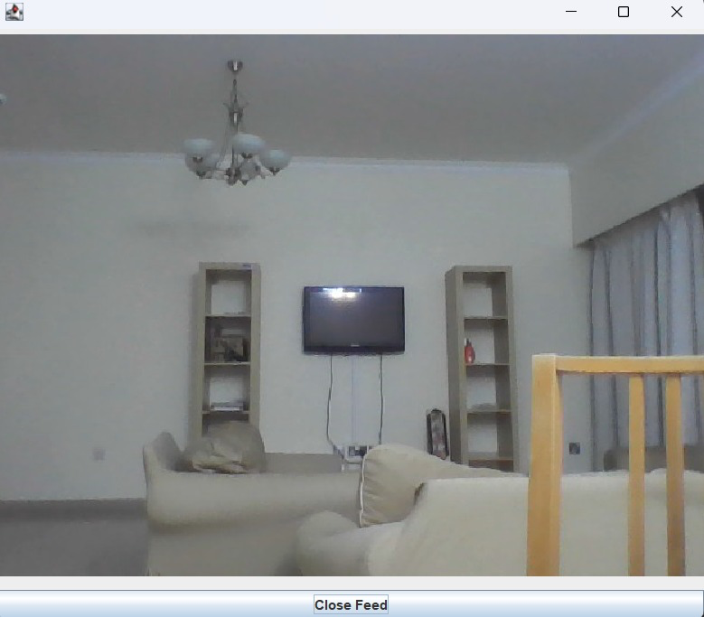

**6**

**If the temperature of the baby rises, the message shows as a notification to the parents. The photo shows an example.**

**5**

**When parents select the live-feed option, the system opens the data from the camera system and displays the real-time stream as shown.**

**Here are some of the alerts that are displayed to inform parents if their baby's temperature rises or if it is normal, as well as to remind them of the baby's feeding schedule.**

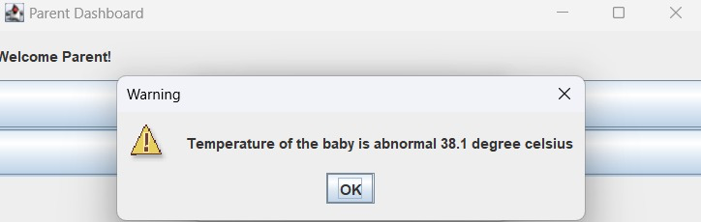

**7**

## Demo for Android

**1**

**The login window appears when starting the app, requesting the user to provide personal information, including the requested credentials (username/password), for completing the registration process.**

**If the system cannot find the user's name or password during the basic flow, an error message is sent to the user, as seen here.**

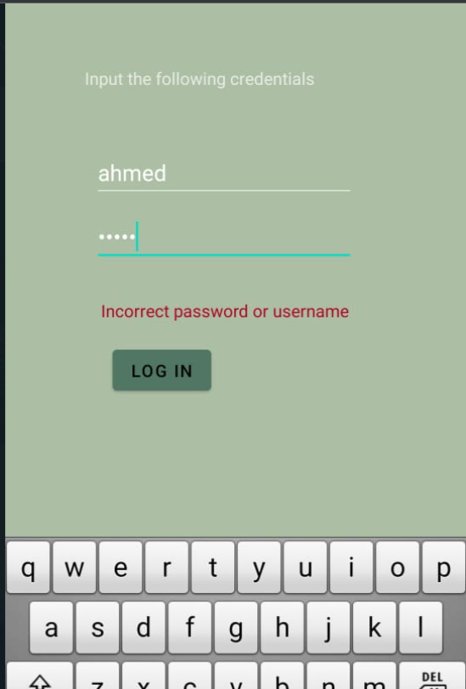

**2**

**After logging in, the user is provided with three main options. The first choice is to open the live feed, and the second is to display the notifications. The user can go back to the main page using the *Exit* button**

**3**

**4**

**When parents select the live-feed option, the system opens the data from the camera system and displays the real-time stream as shown. There are also options to go back.**

**When the system detects an abnormal temperature reading it will send a notification to the parents. Otherwise, it will display message that temperature reading is normal.**

**5**

# Conclusion

The group first presented the feasibility study, followed by the requirements of the system. After that the design phase of the system is presented. Finally, the group came up with two prototypes to address the problem encountered by Ahmed and Mouza, an android mobile application and one desktop application.

# Appendix

**GitHub Link :**

[**Baby-Monitoring-System**](https://github.com/Noah-Yohannes/Baby-Monitoring-System)

## PlantUML code used in Visual Studio Code

|  |
| --- |
| @startuml  class ChildMonitoringSystem{  String Username; String Password; void login(); void logout();  }  class Parents{  String Name; String ID; void Verify();  } class ControllerSW{ int temp; double time; void DisplayVideo(); void CheckTemp(); void TrackMealTime();  } class Camera{ int temp; object video int getTemp(); object getVideo();  }  ChildMonitoringSystem -- Parents  ChildMonitoringSystem -- ControllerSW  ControllerSW -- Camera  @enduml |